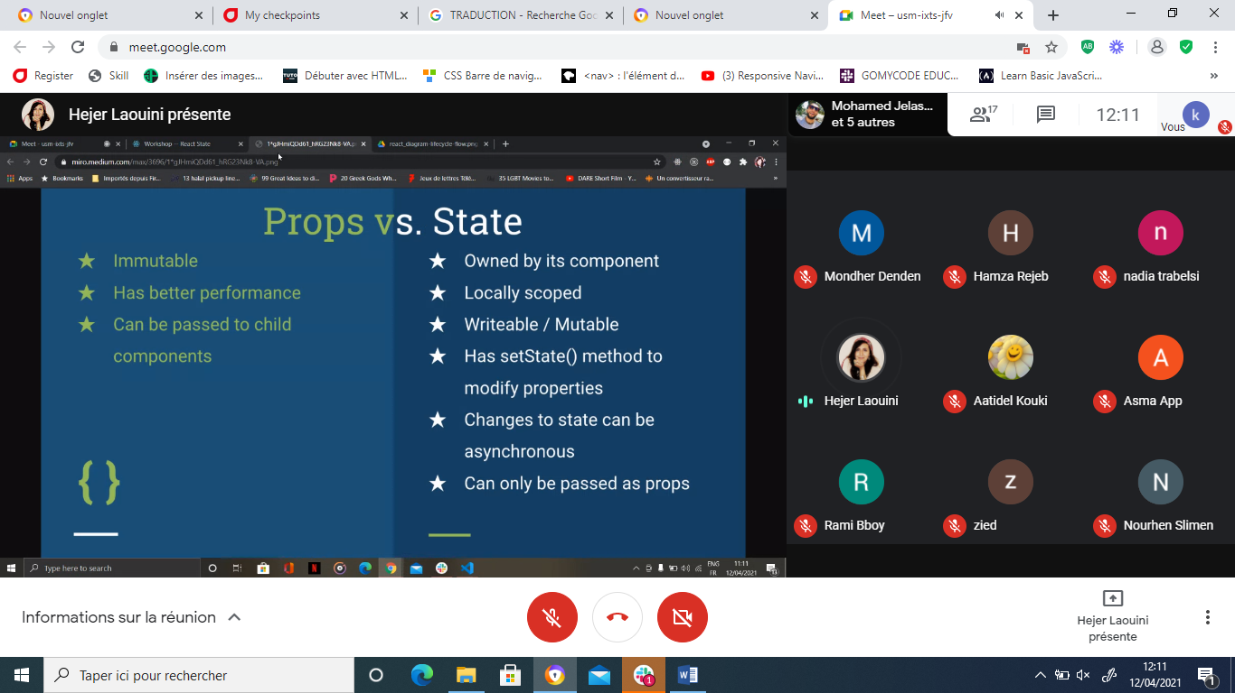

NBADLOU COMPOSANT CLASS

